DESCRETE MATHEMATICS

UNIT- 5

1. PIGEON HOLE PRINCIPLE

ANS – WATCH THIS VIDEO WITH EXAMPLE

https://www.youtube.com/watch?v=3UeHl3UtmGI

2. EULAR GRAPH, PATH, CIRCUIT

ANS - https://www.youtube.com/watch?v=FoiLXsV-bnI

3. HAMILTON GRAPH

ANS - https://www.youtube.com/watch?v=GiClUAJMMtw

4. GRAPH COLORING, chromatic number

ANS - https://www.youtube.com/watch?v=FhXDhUAhHfE

5. ISOMORPHISM

ANS - https://www.youtube.com/watch?v=D-NK7rg6E_k

6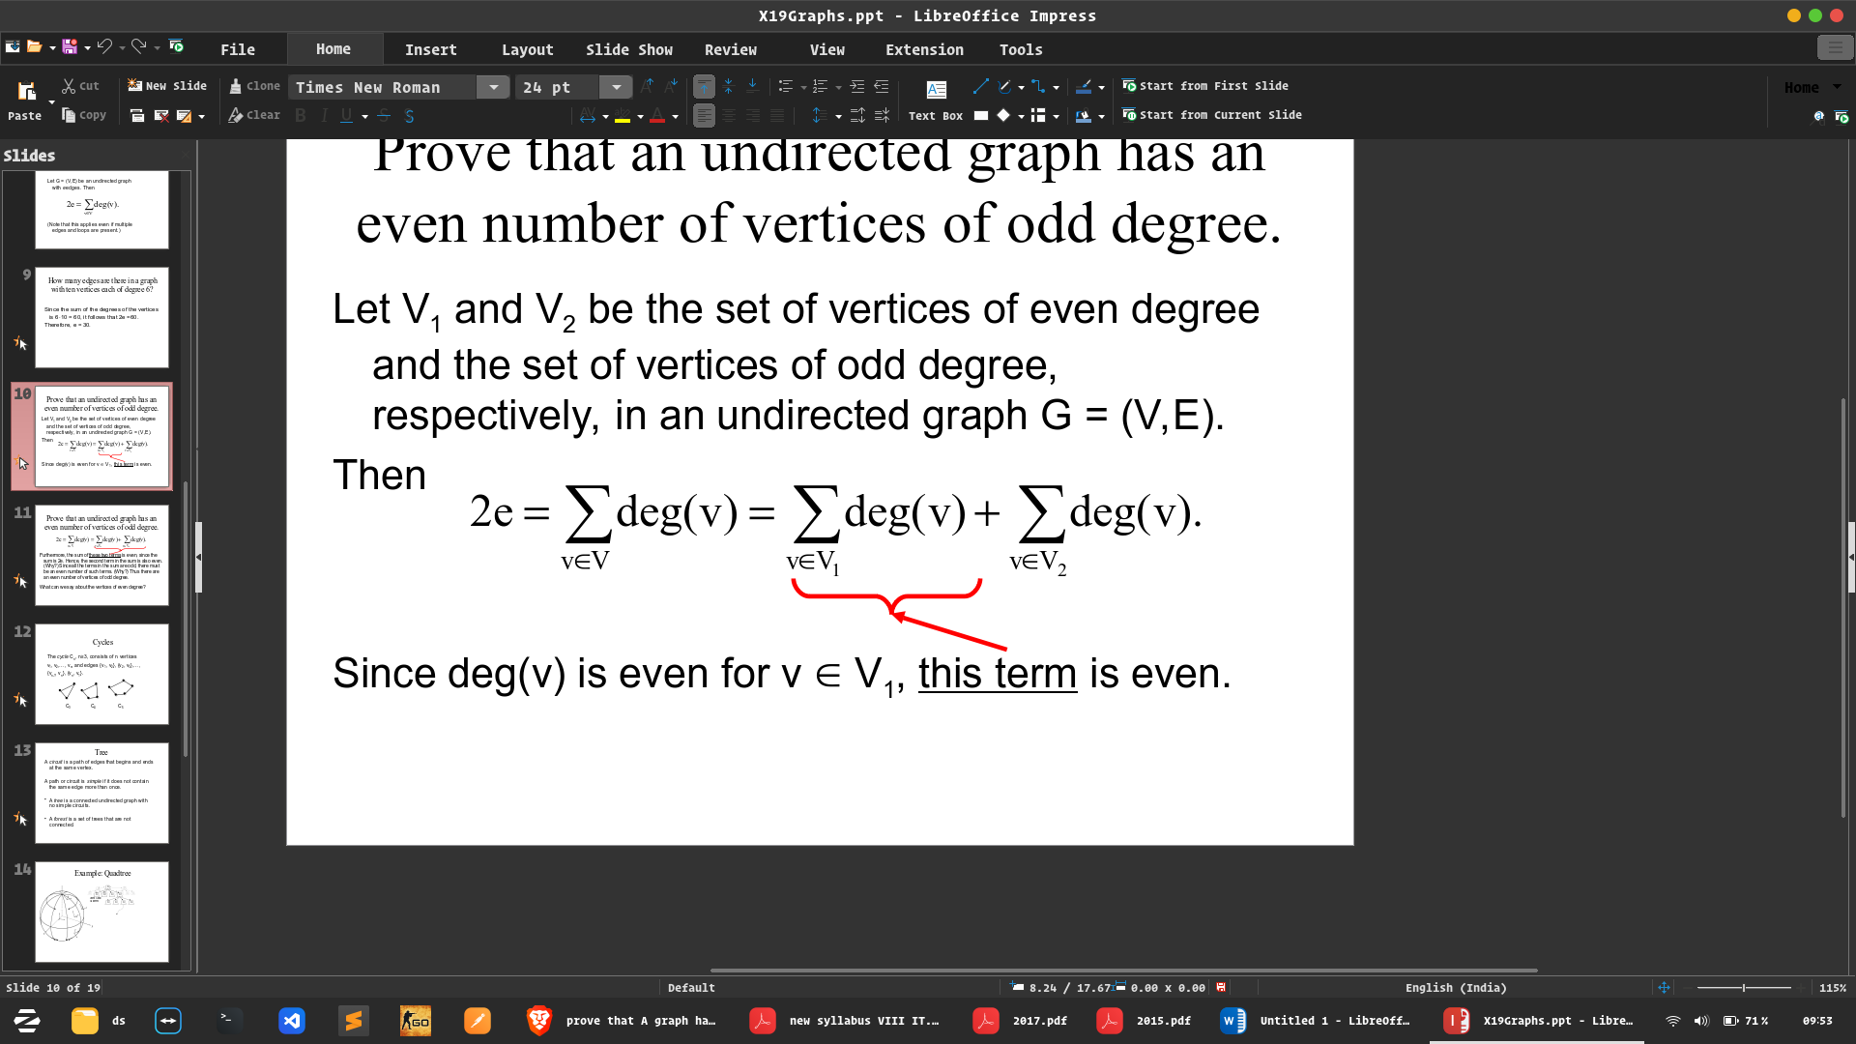. question

UNIT - 4

1. EXPLAIN BOOLEAN ALGEBRA. STATE AND PROVE DEMORGAN THEOREM

ANS - Boolean algebra is the category of algebra in which the variable’s values are the truth values, true and false, ordinarily denoted 1 and 0 respectively. It is used to analyze and simplify digital circuits or digital gates. It is also called Binary Algebra or logical Algebra.

## Boolean Algebra Operations

The basic operations of Boolean algebra are as follows:

* Conjunction or AND operation
* Disjunction or OR operation
* Negation or Not operation

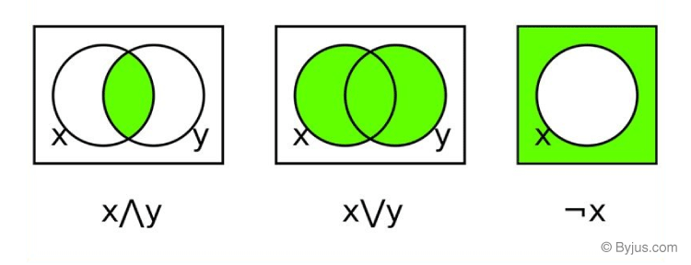

Below is the table defining the symbols for all three basic operations.

|  |  |  |
| --- | --- | --- |
| **Operator** | **Symbol** | **Precedence** |
| NOT | ‘ (or) ¬ | Highest |
| AND | . (or) ∧ | Middle |
| OR | + (or) ∨ | Lowest |

Suppose A and B are two Boolean variables, then we can define the three operations as;

* A conjunction B or A AND B, satisfies A ∧ B = True, if A = B = True or else A ∧ B = False.
* A disjunction B or A OR B, satisfies A ∨ B = False, if A = B = False, else A ∨ B = True.
* Negation A or ¬A satisfies ¬A = False, if A = True and ¬A = True if A = False

## Laws of Boolean Algebra

There are six types of [Boolean algebra laws](https://byjus.com/maths/boolean-algebra-laws/). They are:

* Commutative law
* Associative law
* Distributive law
* AND law
* OR law
* Inversion law

Those six laws are explained in detail here.

### Commutative Law

Any binary operation which satisfies the following expression is referred to as a commutative operation. Commutative law states that changing the sequence of the variables does not have any effect on the output of a logic circuit.

* A. B = B. A
* A + B = B + A

### Associative Law

It states that the order in which the logic operations are performed is irrelevant as their effect is the same.

* ( A. B ). C = A . ( B . C )
* ( A + B ) + C = A + ( B + C)

### Distributive Law

Distributive law states the following conditions:

* A. ( B + C) = (A. B) + (A. C)
* A + (B. C) = (A + B) . ( A + C)

### AND Law

These laws use the AND operation. Therefore they are called AND laws.

* A .0 = 0
* A . 1 = A
* A. A = A

### OR Law

These laws use the OR operation. Therefore they are called OR laws.

* A  + 0 = A
* A + 1 = 1
* A + A = A

### Inversion Law

In Boolean algebra, the inversion law states that double inversion of variable results in the original variable itself.

## Boolean Algebra Theorems

The two important theorems which are extremely used in Boolean algebra are De Morgan’s First law and De Morgan’s second law. These two theorems are used to change the Boolean expression. This theorem basically helps to reduce the given Boolean expression in the simplified form. These two De Morgan’s laws are used to change the expression from one form to another form. Now, let us discuss these two theorems in detail.

**De Morgan’s First Law:**

De Morgan’s First Law states that  (A.B)’ = A’+B’.

The first law states that the complement of the product of the variables is equal to the sum of their individual complements of a variable.

The truth table that shows the verification of De Morgan’s First law is given as follows:

|  |  |  |  |  |  |
| --- | --- | --- | --- | --- | --- |
| **A** | **B** | **A’** | **B’** | **(A.B)’** | **A’+B’** |
| 0 | 0 | 1 | 1 | 1 | 1 |
| 0 | 1 | 1 | 0 | 1 | 1 |
| 1 | 0 | 0 | 1 | 1 | 1 |
| 1 | 1 | 0 | 0 | 0 | 0 |

The last two columns show that (A.B)’ = A’+B’.

Hence, De Morgan’s First Law is proved.

**De Morgan’s Second Law:**

De Morgan’s Second law states that (A+B)’ = A’. B’.

The second law states that the complement of the sum of variables is equal to the product of their individual complements of a variable.

The following truth table shows the proof for De Morgan’s second law.

|  |  |  |  |  |  |
| --- | --- | --- | --- | --- | --- |
| **A** | **B** | **A’** | **B’** | **(A+B)’** | **A’. B’** |
| 0 | 0 | 1 | 1 | 1 | 1 |
| 0 | 1 | 1 | 0 | 0 | 0 |
| 1 | 0 | 0 | 1 | 0 | 0 |
| 1 | 1 | 0 | 0 | 0 | 0 |

The last two columns show that (A+B)’ = A’. B’.

Hence, De Morgan’s second law is proved.

2. CYCLIC MONOID OR CYCLIC GROUP OR GENERATOR QUESTION

ANS - https://www.youtube.com/watch?v=yevF2hxzpjU

3. WHAT IS MONOID?

ANS - https://www.youtube.com/watch?v=BnnivEZi3dU

4. RING

ANS - https://www.youtube.com/watch?v=nL1jOHXgvSQ

UNIT – 3

1. EXPLAIN PARTIAL ORDER SET WITH EXAMPLE?

ANS - A **partially ordered set** (or poset) is a set taken together with a partial order. Formally, a partially ordered set is defined as an ordered pair P =(X,≤) where X is called the ground set of P and ≤ is the partial order of P.

An element u in a partially ordered set (X,≤) is said to be an upper bound for a subset S of X if, for every s ∈ S, we have s ≤ u

Consider a relation R on a set S satisfying the following properties:

1. R is reflexive, i.e., xRx for every x ∈ S.
2. R is antisymmetric, i.e., if xRy and yRx, then x = y.
3. R is transitive, i.e., xRy and yRz, then xRz.

Then R is called a partial order relation, and the set S together with a partial order is called a partial order set or POSET and is denoted by (S ≤).

### Example:

1. The set N of natural numbers form a poset under the relation '≤' because firstly x ≤ x, secondly, if x ≤ y and y ≤ x, then we have x = y and lastly if x ≤ y and y ≤ z, it implies x ≤ z for all x, y, z ∈ N.

2. WHAT IS LATTICE? TYPES OF LATTICE

ANS - Lattice: A POSET in which every pair of element has both a least upper bound and greatest lower bound.

### Types of Lattice:-

1. Bounded Lattice:   
A lattice L is said to be bounded if it has both a greatest and a least element.  
E.g. – D18= {1, 2, 3, 6, 9, 18} is a bounded lattice.

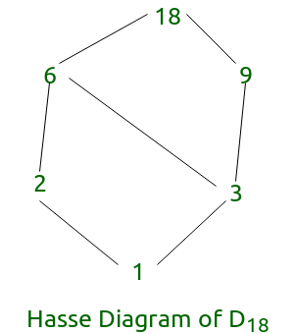

2Complemented Lattice:  
A lattice L is said to be complemented if it is bounded and if every element in L has a complement. Here, each element should have at least one complement.   
E.g. – D6 {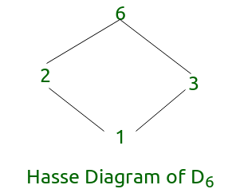1, 2, 3, 6} is a complemented lattice.

In the above diagram every element has a complement.

3.Distributive Lattice:

If a lattice satisfies the following two distribute properties, it is called a distributive lattice.

* x ∧ (y ∨ z) = (x ∧ y) ∨ (x ∧ z)
* x ∨ (y ∧ z) = (x ∨ y) ∧ (x ∨ z)

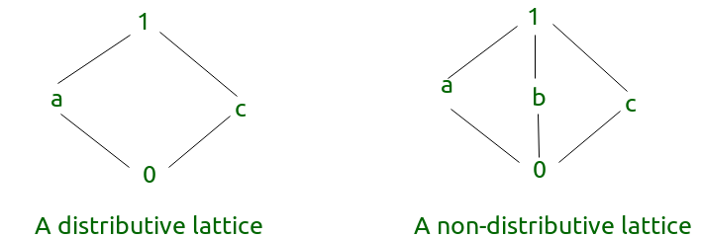

UNIT 2

3. STATE TARSKI FIXED POINT THEOREM

4. PRACTICE IS THAT A TAUTOLOGY TYPE QUESTION

5. WHAT IS PROPOISITIONAL LOGIC AND SEMANTIC?

6. PRACTICE 2016 Q-III

OR MA`AM NE JO KARAYA H COPY M WO REVISE

UNIT – 1

1. ALL GOF AND FOG QUESTION PRACTICE

2, ONTO TYPE QUESTION PRACTICE

3, EQUIVALENCE FUNCTION DEFINITION AND QUESTION PRACTICE